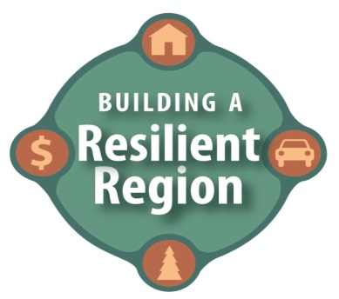 |  | Champion Report Template  Theme Area: Energy  Champions: Jason Edens, Keith Olander,  Sarah Hayden Shaw and Molly Zins  REPORTING PERIOD: April 2016 – June 2016
Goals/Strategies or Action Steps: | What NEW success have you had in moving your theme goals forward over the reporting period?
EI  Energy in our Region | Leech Lake Community Solar  · 200 kW low-income Community Solar array being built this summer  · Fully funded by LCCMR  · Fully subscribed through energy assistance  · First of its kind in the nation  Solar for Schools  · Region 5 and RREAL entering into negotiations with Excel energy for the grant agreement for RDF funding for the 1.5MW solar for schools project  · 5 regional school districts (Royalton, Brainerd, Pequot, Pine River, Leech Lake)  · 8 buildings  · Energy curriculum included with project  · Massive project for our region!  · Partnership between Region 5 Development commission /RREAL/tenK solar  · Kick off meeting was held on April 22  Central Lakes College solar array is installed!  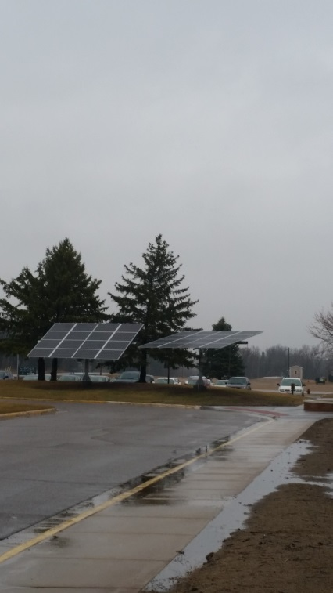  It is now wired in and CLC staff look forward to being able to share its effectiveness in reducing traditional consumption.  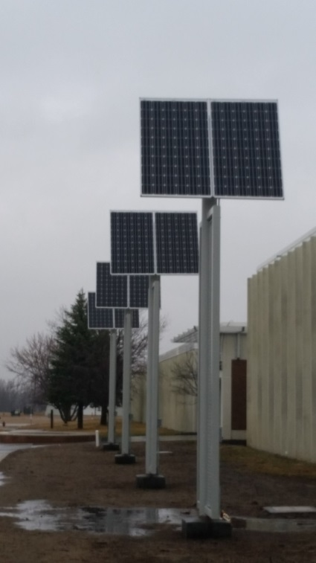  Xcel Energy and MNSCU have reached agreement on a large system wide partnership to assist MNSCU in reducing its carbon footprint as well as including education components about energy efficiency and renewable energy concepts.  Renewable Energy Equipment Grant Program  · Community Action Agencies can currently respond to an RFP to do $150k of low-income roof-top solar  · Dept. of Commerce  · RREAL helped create this fund, but it is only available to CAPs  National Community Solar Partnership  · RREAL, Fresh Energy, Dept. of Commerce and MNSEIA are all participating in the National  Community Solar Partnership (NCSP)  · NCSP is an Obama Administration Initiative to make solar more accessible to low-income populations.  · Recent meeting at the White House gave our Minnesota delegation the opportunity to talk about the trail-blazing work we’re doing here in our region.  Community Solar for Community Action: A new model of low-income energy assistance project is proceeding very well and receiving some national attention. Interested parties (utilities, developers, community action agencies, financiers, advocates, low-income households) participated in stakeholder meetings last summer to assist with planning.
Increase energy efficiency | 2016 CERTs Seed Grants  The Clean Energy Resource Teams are excited to announce 39 Seed Grant awards to organizations in the seven Minnesota CERT regions. Each region awarded around $20,000 worth of grants, catalyzing energy efficiency and renewable energy across the state. CERTs has awarded over $1 million in Seed Grants to 269 projects since 2006.  Central CERTs region grants include:  Lake Region Takes Root: Solar in the Garden (Fergus Falls), Detroit Lakes Public Utilities: Community Solar Project, AgInspire: Renewable Energy Education Kits, Paws and Claws Animal Shelter: 40 kW Solar Array (Hackensack), Lutheran Church of the Cross: 7.56 kW Ground-Mount PV System Project  (Nisswa), Honor the Earth: Pine Point Village Solar Thermal, Pine Point Village (White Earth Reservation). More information on the grants can be found at: www.cleanenergyresourceteams.org/rfp  Made In Minnesota Solar Incentive Program accepting applications through February:  https://mn.gov/commerce/industries/energy/solar/mim/  Made in Minnesota Solar Thermal Rebate is statewide and can be harvested in any utility. 25% of total project costs (up to $2500 for residential projects and up to $25,000 for commercial projects).  Renewable Energy Equipment Grant Program (REEGP) has been reauthorized pending passage of energy bill in special session which provided $150,000 for Community Action Agencies to install solar air heat, biomass and potentially PV now.  A busy and exciting time for Youth Energy Summit (YES!) participants  For the Youth Energy Summit (YES!) program, the last few months of 2015 included two successful Fall Summits, welcoming two new YES! Coordinators, reconnecting with a YES! alumna, and more. 240 students and coaches attended the 8th annual Fall Summit, held at Saint John’s University on September 30th. This excitement was echoed two weeks later on October 14th as 76 students and coaches attended the 2nd annual Northeastern YES! Fall Summit at Laurentian Environmental Center. Sarah Hayden Shaw is the newest YES! Coordinator and she will be coordinating teams in Aitkin, Crow Wing, Cass, Wadena, Ottertail and Wilkin counties.
What future activities has your theme prioritized for the coming year?
- Two groups on CSG. One was in BPU territory. One was in MN Power Territory.
- Low income access common theme.
- Getting projects going in different utility territories.
- Biomass - education on use of biomass for energy. Identify communities. Outreach, education and tours. Broader understanding of options.

Energy
Energy Issue I (EI)
Energy in our region: Not all of the jobs that were lost in the past ten years were to developing countries with lax regulatory oversight and low wages, many jobs were lost to advancements in technology and related productivity gains. Because the region has many companies that are working within energy related fields, developing breakthrough technology in energy production will be critical for advancing the industry cluster and the region.

Energy Issue I Goal
Increase energy efficiency: Create a more energy efficient region through working with utilities and emphasizing energy efficiency. Employ education and outreach to capitalize on technological advancements in energy including smart grid technologies and renewable energy conducive to our region such as geothermal, solar, wind, biomass, energy storage and hydro power.

Recommendation 1
Public/private collaboration: Increase collaboration between public and private sectors to implement new energy technologies, including state and federal financing for private/public partnerships.

Action Step A
Partnerships: Work with Habitat for Humanity to build additional energy efficient homes and work with Community Action Partnership (CAP) agencies to weatherize homes.
Action Step B
Priorities: Target group homes and programs serving the low-income, senior, and disabled populations.
Action Step C
Information sharing: Add utilities to email notification for agendas of city/county/Region 5 Development Commission’s EDA/HRA/Planning Commissions, etc. so the utilities can review for possible projects. EDA to send email to utilities with prospects/commercial building projects.
Action Step D
Seek out information: Utilities regularly ask EDAs for information about possible commercial building opportunities.
Action Step E
Identify contacts: Create a contact list of utility personnel that all the utilities can refer to regionally.
Action Step F
Rebate information: Post utility rebates on the new Resilient Region website and link to utility websites.
Action Step G
Coordinate between utilities: Set up a regular schedule for utilities to meet on the issues of energy efficiency and low-income programs.
Action Step H
Utility contact information: Inventory regional utilities and post a regional utility map and contacts on the Resilient Region website.
Action Step I
Policy change: Collectively address the policy issue of inequity between credits for BTUs and/or KWHs saved. Ask for support from energy advocate agencies and local governments.
Action Step J
Educating farmers: Support energy efficiency in agriculture. Plan a statewide conference for the agriculture industry and farmers focusing on energy efficiency. Support the Minnesota Project’s Dairy Initiative on energy efficiency.
Action Step K
Educate commercial and industrial: Campaign for commercial and industrial efficiency.

Recommendation 2
Support renewable energy requirements: Energy users support utility companies in meeting renewable energy requirements

Action Step A
Standardize rebates: Standardize rebates across utilities.
Action Step B
Neighborhood energy use: Work with Center for Energy and the Environment (CEE) to conduct neighborhood energy challenges. Educate residential consumers.
Action Step C
Consumer energy use: Use existing software (MyMeter) to encourage customers to manage usage.

Action Step D
Case studies: Publicize case studies of families that have utilized programs that save energy.
Action Step E
Publicize programs: Encourage utilities to list programs available for low-income residents
Action Step F
Low-income focus: Encourage utilities to lead discussions around low-income gaps.
Action Step G
Coordination and promotion: Coordinate and promote existing efficiency programs

Recommendation 3
Conservation and renewable technologies: Encourage and teach conservation and advance practical renewable energy technologies that have a reasonable return on investment. Teach people how to conserve energy, manage energy demand & about new technologies – without bias as to type of energy source. Focus on conservation. Discuss/teach how energy sources contribute to pollution.

Action Step A
Economic development: Create an energy incubator campus, leverage existing expertise, and create target incentives to advance the commercialization of clean, green, sustainable enterprises
Action Step B
Solar access: Ensure access to solar energy for all housing.
Action Step C
Equipment: Help finance energy efficient business equipment for commercial, industrial and agricultural enterprises.
Action Step D
Policy: Incentivize energy conservation through such actions as tax incentives for home owners and businesses that utilize solar, wind, etc. Reduce regulations that impede renewable energy production. Promote policy that supports decentralized energy production. Provide incentives such as cost share incentives and rebates to help energy users adopt renewable energy technologies.
Action Step E
Energy production: Focus on small scale energy production. Cultivate the hazardous energy sources like nuclear. Focus on research not production.
Action Step F
Research: Support research on conservation and renewable technologies.
Action Step G
Waste to energy: Support opportunities to turn waste into energy.
Action Step H
Service delivery planning: Engage in planning for brown-out/black-out times when utility companies are not able to operate.
Action Step I
Infrastructure: Pursue solutions to building local renewable energy infrastructure (i.e. electric car stations).
Action Step J
Education: Utility companies should partner with schools to provide classroom-based education on renewable energy.

